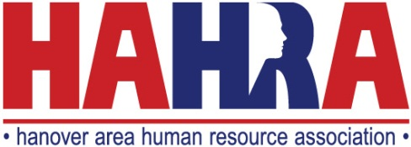

HAHRA Meeting Sponsorship Program

The Meeting Sponsorship Program is designed to bring together HR related businesses, service providers and our general membership. This is a fantastic opportunity for businesses to present and promote their product or service to HR professionals in the Hanover area. It also provides our members with an opportunity to evaluate various HR related tools to help them in performing their roles in human resources.

The goal of the Meeting Sponsorship Program is to provide HAHRA members with access to organizations and vendors that benefit their company and support human resources professionals.

Benefits | Total Sponsorship Cost
Chapter Meeting Sponsor  - 2 complimentary seats for the event  - Table to display information, promotional items, and network with HAHRA members at one monthly chapter meeting  - Up to three minutes to address audience during event  - Online and Social Media Marketing promotion | $300
Seminar Sponsor  - 4 complimentary seats for the event  - Table to display information, promotional items, and network with HAHRA members at one seminar  - Exclusive Sponsorship Opportunity  - Up to five minutes to address audience during event  - Online and Social Media Marketing promotion  - Regionally Distributed Print Marketing | $1,000

Invoices will be emailed directly to you after Sponsorship is confirmed.

HAHRA offers the ability to securely pay your invoice via credit card directly online or if you prefer, you can print out the invoice and mail your payment directly to our P.O. Box at:

HAHRA P.O. Box 1454 Hanover, PA 17331

Sponsorship Application

Company Name:

Contact Name:

Email:

Address:

City: State: Zip:

Phone:

Sponsorship Type (choose one):

Chapter Meeting Sponsor Chapter Seminar Sponsor

Please send your corporate logo in a jpeg or png format for use in pre-meeting marketing materials to aseebold@WellSpan.org.

Please contact Andy Seebold, Chair of HAHRA Sponsorship Committee, at 717-851-4171 or aseebold@wellspan.org with any questions.

Thank you for partnering with HAHRA!

